# Systems Engineering Portfolio: Automatic Whiteboard Rubber

The automatic whiteboard rubber, for teachers that are too busy teaching to be doing menial labour.

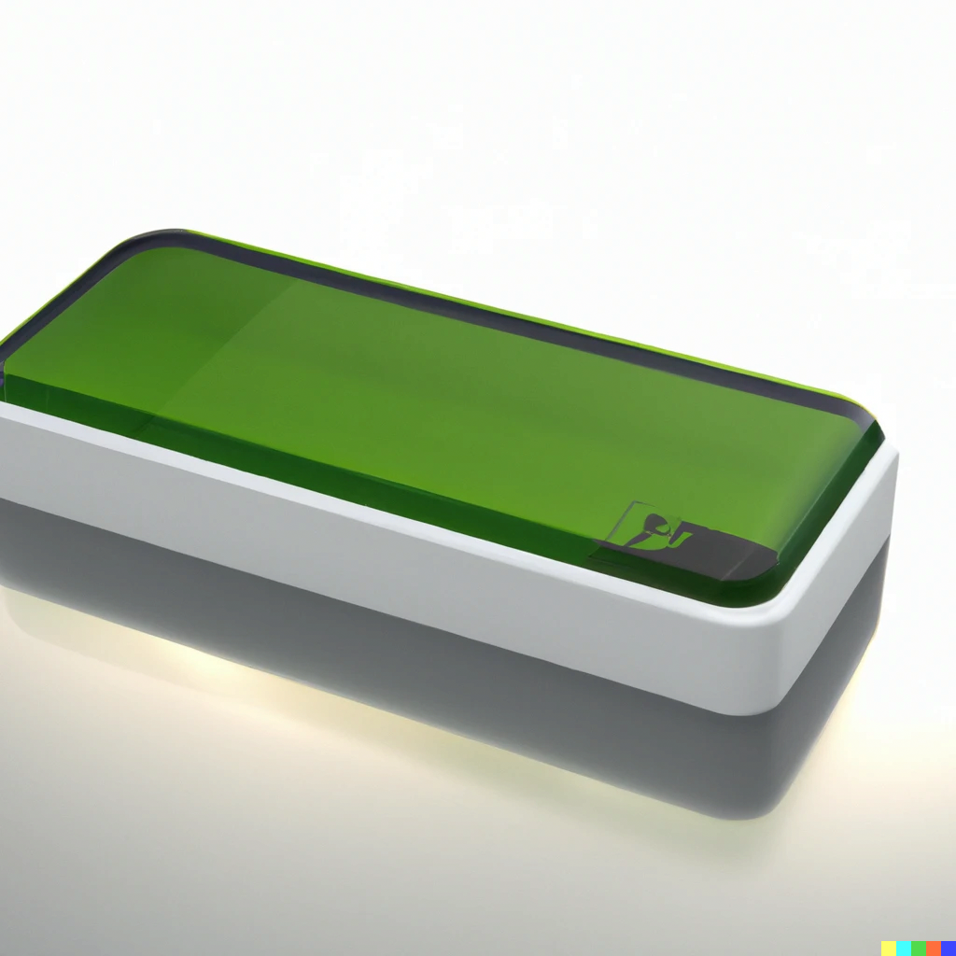

[contact@rdang.dev](mailto:contact@rdang.dev)

[rdang.dev](https://rdang.dev)

VCE Systems Engineering Project

Contents:

* Todo(temporary), located at <https://boards.rdang.dev/b/s2WGQaGN4AZGfbFQp/systems-engineering>
* Introduction
* Inspirations
* Design Brief
  + Timeline, GANNT Chart
  + Potential Challenges
* Client Profile
  + Requirements
  + Constraints
  + Potential Challenges
  + Considerations
* Market Research
* System Ideation
* Timelines
  + Projected:
  + Frfr:
* Research
  + Components
  + Materials
  + Tools
* Initial Plans and Designs
* Risks and Health Assessment(OHS)
* Design #1
  + The Design itself
  + Tools and Equipment needed
  + evaluation
* Design #2
* Design #3
* ‘Finalised’ design
* Iteration #1
* Iteration #2
* Iteration #3
* Evaluation Report
* Gallery
* Credits and Bibliography

Introduction

Inspirations

Design Brief

Client Profile

The main client that this product is targeted at is older teachers- specifically teachers who are more interested in teaching than menial tasks, just like my Physics & Systems Engineering teacher.

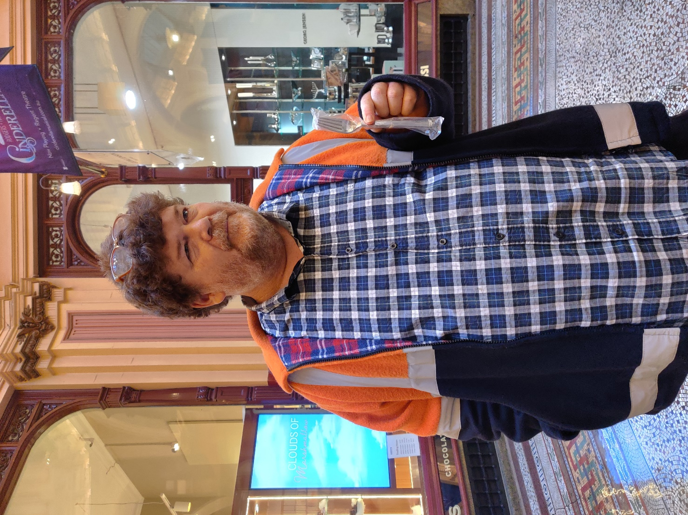

Figure : Mr. Richardson showing off his 20 dollar fork.

Initial Plans and Designs

Risks and Health Assessment(OHS)

Tools and Equipment needed

Design

Finalised Designs

Iterations

Evaluation Report

Gallery

Gallery is located at <https://gallery.rdang.dev>

Preview:

Credits and Bibliography

rtqaerta